ISWK STUDENTS’ STUPENDOUS PERFORMANCE IN CLASS 12 OF 2018: 7 STUDENTS SCORE 100 IN INFORMATICS PRACTICES

The jubilant students of Indian School Wadi Kabir have the world at their feet with their outstanding success in Class 12 Board Examinations conducted by the CBSE in March 2018, marking yet another year of excellent academic and personal achievements at the school.
The hard work put in by all the 259 students, who appeared for the AISSCE, has borne fruit. Of the 145 students of the Science stream, Vaidehee Thakur has topped the list of successful candidates with an aggregate of 97.4% followed by Aswin Muraleedharan scoring 96.6% in the aggregate and Nikitha Michlin Alex adding up an impressive 96.4%. Vaidehee Thakur is also the topper in Computer Science with 99%. Jovita is the topper in English with 98%. Aswin Muraleedharan has scored 100% in Mathematics.
Of the 114 students of the Commerce stream, Jobin Jacob Kannannuparampil stands first with 96.4% aggregate followed by Arya Sudheer and Suhana Mohammed with 95.6% in the second place. In the third place with an aggregate of 95.2 % we have Praneel Malloli Meethal.
Informatics Practices deserves a very special acclaim as they presented an amazing performance with 7 students scoring 100 marks and thus setting a record. The triumphant toppers are Devayani Hebbar, Raksha Jagadeesh Patil , Rushab Jain , Abdullah Feroz Ansari, Aishwarya Balakrishnan, Ragendu Suresh Nair and Sandhra Jyothis Tomley.
The School Management, Principal and Staff congratulate the students and their parents for their brilliant results.

The following is the list of toppers in both the Science as well as Commerce streams.
ENGLISH | JOVITA DANTIS VARGHESE | 98
ACCOUNTANCY | VINEETHI RAVINDRANATHAN | 97
ECONOMICS | ARYA SUDHEER  SHREYA NAIR | 98
BUSSINESS STUDIES | ARYA SUDHEER  JOBIN JACOB KANNANNUPARAMPIL  S. AYISHWARYA | 99
ENTREPRENEURSHIP | SHREYA NAIR | 98
INFORMATICS PRACTICES | DEVAYANI HEBBAR  RAKSHA JAGADEESH PATIL  RUSHAB JAIN  ABDULLAH FEROZ ANSARI  AISHWARYA BALAKRISHNAN  RAGENDU SURESH NAIR  SANDHRA JYOTHIS TOMLEY | 100
COMPUTER SCIENCE | VAIDEHEE THAKUR | 99
BIOLOGY | ARAVIND K PRASAD | 97
CHEMISTRY | JOVITA DANTIS VARGHESE  VAIDEHEE THAKUR  ASWIN MURALEEDHARAN ULANAT | 99
PHYSICS | NIKITHA MICHLIN ALEX | 98
MATHEMATICS | ASWIN MURALEEDHARAN ULANAT | 100
THE SUBJECT TOPPERS ARE:

The photographs of the student toppers appear below:
SCIENCE STREAM
FIRST RANK | SECOND RANK | THIRD RANK
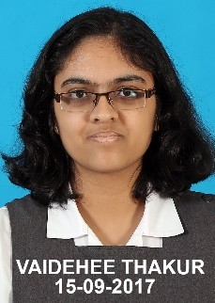 | 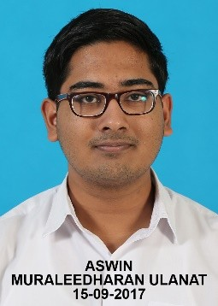 | 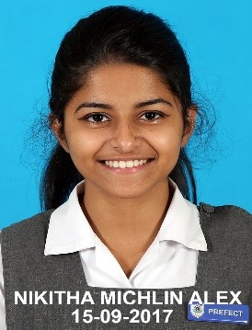
VAIDEHEE TAHKUR (97.4%) | ASWIN MURALEEDHARAN ULANAT (96.6%) | NIKHITHA MICHLIN ALEX (96.4%)

COMMERCE STREAM
FIRST RANK | SECOND RANK | THIRD RANK
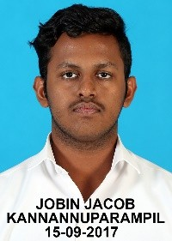 | 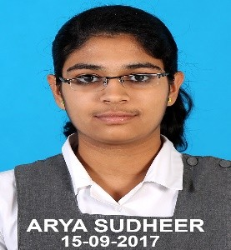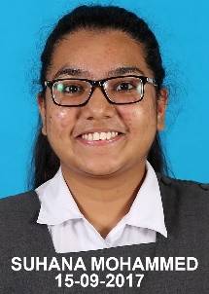 | 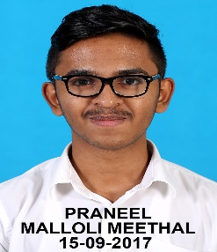
JOBIN JACOB KANNANNUPARAMPIL  (96.4%) | ARYA SUDHEER SUHANA MOHMMED  (95.6%) (95.6%) | PRANEEL MALLOLI MEETHAL (95.2%)

SUBJECT TOPPERS
INFORMATICS PRACTICES (100%)
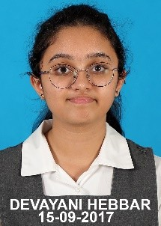 | 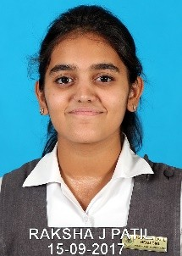 | 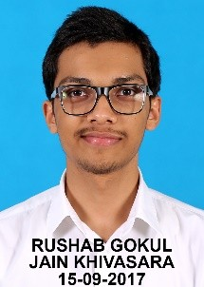 | 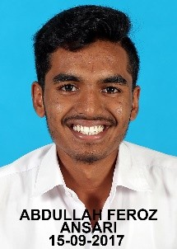 | 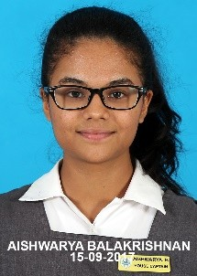 | 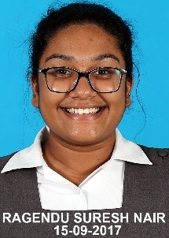 | 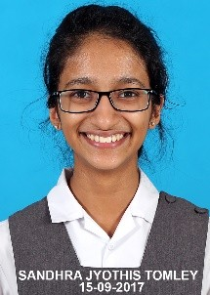
DEVAYANI HEBBAR | RAKSHA JAGADEESH PATIL | RUSHAB JAIN | ABDULLAH FEROZ ANSARI | AISHWARYA BALAKRISHNAN | RAGENDU SURESH NAIR | SANDHRA JYOTHIS TOMLEY

MATHEMATICS (100%)
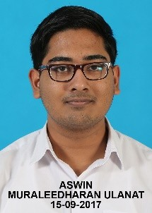
ASWIN MURALEEDHARAN ULANAT

ENGLISH | CHEMISTRY
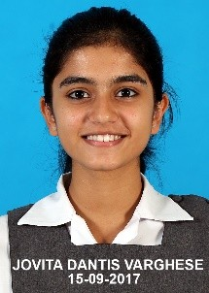
JOVITA VARGHESE  (98%) | ASWIN MURALEEDHARAN ULANAT (99%) | VAIDEHEE THAKUR (99%) | JOVITA VARGHESE  (99%)

BIOLOGY | PHYSICS
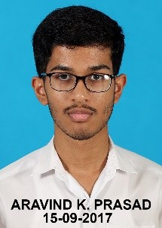
ARAVIND K PRASAD (97%) | NIKITHA MICHLIN ALEX (98%)

ECONOMICS |  | ENTREPRENEURSHIP | ACCOUNTANCY
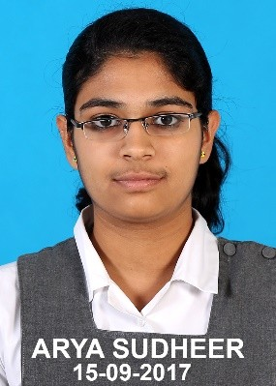 | 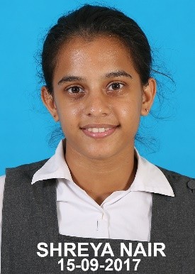 | 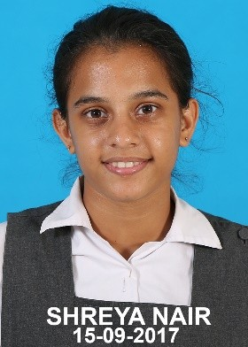 | 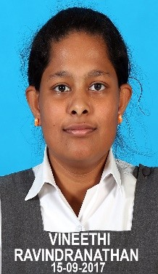
ARYA SUDHEER (98%) | SHREYA NAIR  (98%) | SHREYA NAIR  (98%) | VINEETHI RAVINDRANATHAN  (97%)

BUSINESS STUDIES
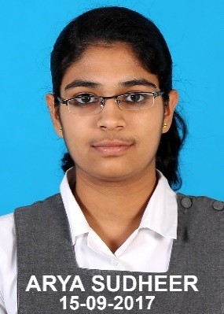 | 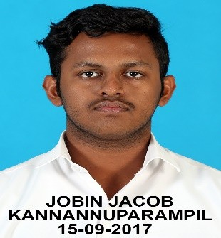 | 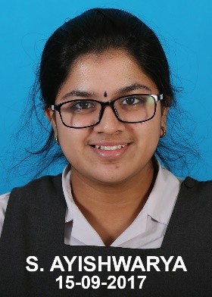
ARYA SUDHEER (99%) | JOBIN JACOB KANNANNUPARAMPIL  (99%) | S. AYISHWARYA  (99%)
COMPUTER SCIENCE
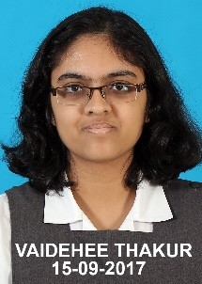
VAIDEHEE THAKUR (99%)

