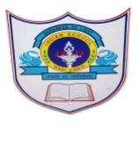
INDIAN SCHOOL AL WADI AL KABIR
DEPARTMENT OF COMPUTER SCIENCE
ANNUAL SYLLABUS
2018-2019
CLASS: II
MONTH | NO. OF WORKING DAYS | LESSONS | ACTIVITIES
APRIL  04-04-2018 – 30-04-2018 | 06 | Unit 1. Nano loves his computer  (To take care of the computer in different ways) | 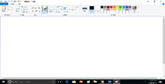  MS Paint:  Drawing simple pictures in MS Paint.  Using shapes
MAY  01-05-2018 – 31-05-2018 | 08 | Unit 2. Computer – a smart machine  (Different uses of computer)  - Draw and colour  - Do sum  - Read and write  - Listen to music | Pre -Term Examination.
AUGUST  01-08-2018- 30-08-2018 | 06 | Unit 3 – Computer Everywhere  (How and where the computers been used daily life)  - At home  - At school  - In office  - In shops  - In hospitals  - At airports and railways  - In aero planes  - In bank  - While travelling | MS Paint:  Drawing simple pictures in MS Paint.  Using pencil tool.  Project1 page :25  Midterm practical exam marks(10)

