INDIAN SCHOOL AL WADI AL KABIR

Class: VI | Department: Computer Science | Date of submission:12/08/2019
Holiday Homework No:1 | Topic: MS Excel | Note: Holiday homework will be graded during practical session , practice in holidays

Create the following worksheet

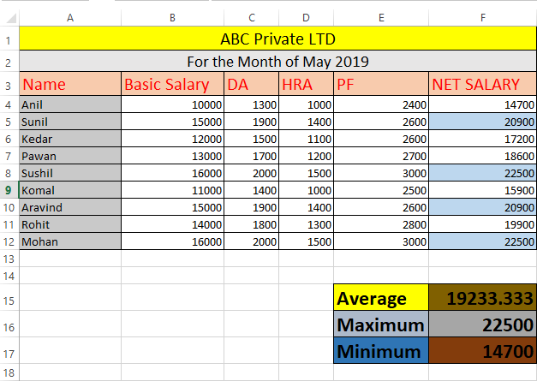

Now, follow these instructions:
- Merge and center the cells of Row1 and Row 2 and fill color
- Find out the net salary using formula ‘=B4+C4+D4+E4’ into F5
- Copy the formula to the rest of the cells
- Change the font to ‘Calibri’
- Find the Average, Maximum and Minimum of net salary using function
- Fill color to the Name field as shown in the workbook
- Fill color to average, maximum and minimum value
- Apply conditional formatting to the net salary greater than 20000
- Apply all border on the table
- Save the workbook as Employee salary.

