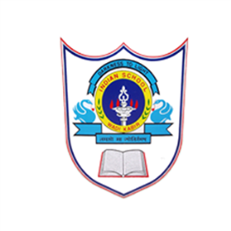

INDIAN SCHOOL
AL WADI AL KABIR

2019-2020
CLASS - XII

Holiday homework is an attempt to channelise the creative energy of the children. Doing it in the right spirit with enthusiasm will make it a great learning experience. Make sure that your work is neat, presentable, and original and follows to the guidelines.

CLASS 12 - PHYSICS
- PHYSICS JOURNAL
- PHYSICS INVESTIGATORY PROJECT
- WORKSHEET : CHAPTER 3 ELECTRIC CURRENT
Prepared by Mr. William S

CLASS 12 - CHEMISTRY
- CHEMISTRY JOURNAL ( 4 EXPERIMENTS)
- CHEMISTRY INVESTIGATORY PROJECT – DATA COLLECTION ( AS INSTRUCTED)
- WORKSHEET :
- Surface Chemistry
- Chemistry in everyday life

Prepared by Ms. Jasmin J

CLASS 12 - BIOLOGY
JOURNAL WORK
PROJECT WORK
WORK SHEET - Ecology 1

Prepared by: Ms. Rejitha Sajith

CLASS 12 - ENGINEERING GRAPHICS
1. Complete the practical journal which includes 15 isometric view drawings with the given views and also find out and draw the hidden views.

2. Complete the 15 collabcad investigatory project which includes 15 computer drawings.

Note: All dimensions in millimeters
Date of submission : On Reopening day
Prepared by Ms. Aiswarya D

HOD – SCIENCE
26.05.19

