INDIAN SCHOOL AL WADI AL KABIR

|  |  |  |
| --- | --- | --- |
| **Class: XII Informatics** | **Department: Computer Science** | **Date of submission:04/08/2019** |
| **Worksheet No:6** | **Topic: Lab Exercises (11-15)** | **Note: Holiday Home Work** |

1. An Election is conducted between 3 candidates. There are N number of voters. By clicking Next Voter Button, Textbox (Name of the Voter), Text Area (Result) and Radio Buttons need to be cleared. By clicking Results, the votes obtained by each candidate and the winner candidate to be displayed in text area. Exit button should exit program.

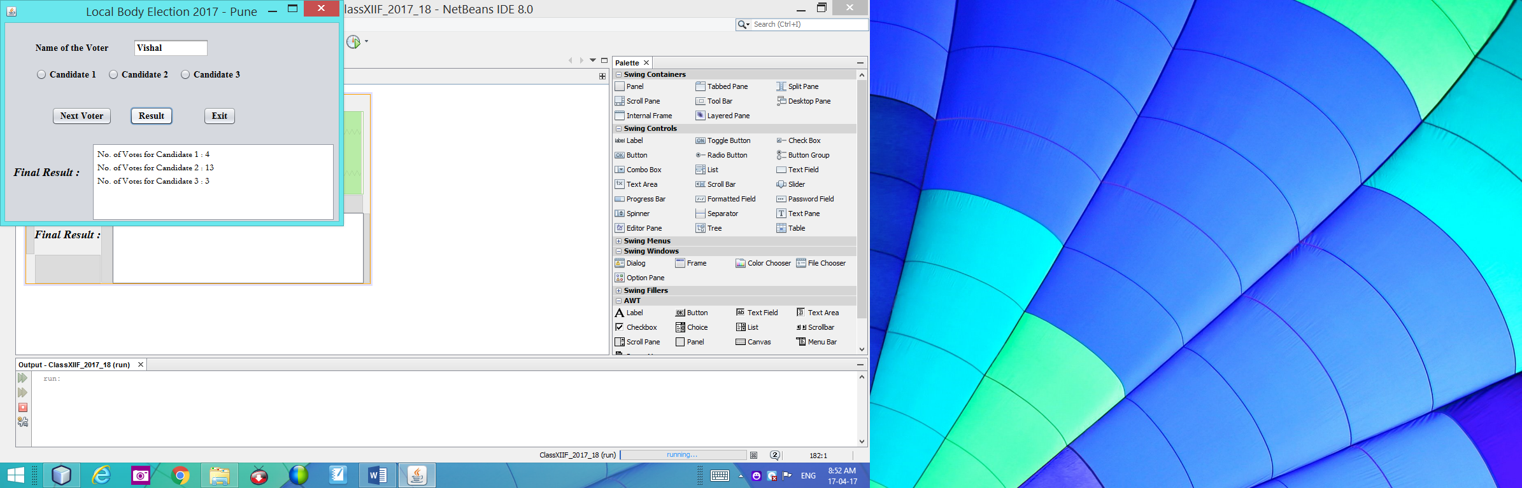

1. ABN Shipment Corporation imposes charges to customers for different product .The shipment company costs for an order in two forms: Wholesalers and Retailers . The cost is calculated on unit basis as follows:



|  |  |  |
| --- | --- | --- |
| For Units | Price for wholesalers (per unit) | Price for retailers (per unit) |
| 1-15 | Rs. 50/- | Rs. 60/- |
| 16-20 | Rs. 45/- | Rs. 56/- |
| 21-30 | Rs. 40/- | Rs. 50/- |
| 31-50 | Rs. 35/- | Rs. 45/- |
| >50 | Rs. 30/- | Rs. 40/- |

1) Write the code to disable the text boxes txtTCost and Wholesaler as default option when the form is active.

(2) Write the code for Calculate Cost command button(cmdCalc)

(i) Display the discount price in txtDisc if special customer is selected. Discount is at the rate of 10% of Total cost.

(ii) To display total cost.(Total cost = Ordered Unit * Unit Price-Discount Price)

(3) Write the code for Exit Button (cmdExit) to exit the application.

1. NDPL generates computerized bills for its customers on every month the bill is generated for four consumption as follows.



|  |  |  |  |
| --- | --- | --- | --- |
| **Consumption Section** | **1st 200 Units (Rs. / Unit)** | **Next 200 Units (Rs. / Unit)** | **Above 400 Units (Rs. / Unit)** |
| Domestic Light | 2.45 | 3.95 | 4.65 |
| Non Domestic Light Up to 10 KW | 5.40 | 5.40 | 5.40 |
| Non Domestic Light Above 10 KW | 4.92 | 4.92 | 4.92 |
| Agricultural Power Up to 10 KW | 1.55 | 1.55 | 1.55 |
| Agricultural Power Above 10 KW | 9.84 | 9.84 | 9.84 |
| Industrial Power Up to 10 KW | 5.05 | 5.05 | 5.05 |
| Industrial Power Up to 10 KW | 4.40 | 4.40 | 4.40 |

(i) Create a Java Desktop application using Swing controls to read the number of units consumed and print out the charges. Design the IDE by taking Consumption Sections into JRadioButtons and the Up to 10KW and above 10KW in JCheckBox controls. Bill need to be displayed using JOptionPane. While coding do the following also:

When you click on Domestic Light button, disable the Up to 10KW and Above 10KW check boxes. When you click on other three buttons except Domestic Light in Consumption Section, both JCheckBox control will be set to enabled.

(ii) Write the code for Exit button to exit the application.

1. Create a Java Desktop application to find the area of circle,rectangle,circumference of circle and area of square. Design the IDE and programming logic with two JPanel containers contains the following

- JPanel1. Add three JRadioButtons and set the buttons as : Circle, Rectangle and Square

- JPanel2. Add four JCheckBoxes and set the buttons as :Area,Perimeter,Circumference



When you select an option from JPanel1, it automatically hide the facilities which is not appropriate for selected option. Similarly, apply the same for JTextfield controls also.

(i)Write the code for circle JRadioButton to make available the display controls which are appropriate for Circle operation.

(ii)Write the code for Rectangle JRadioButton to make available the display controls which are appropriate for Rectangle operation.

(iii)Write the code for Square JRadioButton to make available the display controls which are appropriate for Square operation.

(iv)Write the code for Calculate button to calculate the desired operations which you choose from JRadioButtons.

(v)Write the code for Exit button to exit application.

1. Hotel Hill Top Inn in Ooty plan to go for computerization in order to meet the workload during tourist session. There are three types of rooms available in Hill Top.



(a)Write the code to disable the text boxes txtRate,txtAmount.txtFacility when the form activated.

(b)Write the code for cmdClear command button to clear all the textboxes.

(c)Write the code for cmdRate to calculate rate of the room per day and display it in txtRAte depending on the type of room selected by the customer. Rate is calculated according to the following table:

|  |  |
| --- | --- |
| **Room Type** | **Rate per day** |
| Single | 1500 |
| Double | 2800 |
| Delux | 5000 |

(d)Write the code for cmdAmount to calculate the total amount and display it in txtAmount.The total amount is calculated by first finding the cost of facilities selected by the customer. Cost of facilities is calculated according to the following table:

|  |  |
| --- | --- |
| **Facility** | **Cost** |
| Tour Package | 7000 |
| Gym | 2000 |
| Laundry | 1000 |

**Note : Write these 5 Exercises with coding in your Practical Note Book and submit to your Informatics Practices Teacher on or before 04/08/2019.**