 | INDIAN SCHOOL AL WADI AL KABIR
Holiday Home work
Class: XI Sub: Informatics Practices M.M: 70

Qn No. |  | Marks
1 a) | What are type of printers available? Which type is more speedy? | 2
1 b) | What is the function of Memory? What are the measuring units of a memory? | 1
1 c) | What do you mean by ports? Write any 4 types of ports. | 2
1 d) | What are the difference between a Compiler and Interpreter? | 2
1 e) | Write any two features of Electronic Spreadsheets. | 1
1 f) | Define : Phishing | 1
1 g) | What do you mean by Adware? | 1
2 a) | Write the difference between isEnabled( ) and setEnabled( ) methods in java. | 1
2 b) | Tanvir wants to enter password in login page to open his application. When he types his password it shouldn’t be visible to others! Suggest him a suitable control! | 1
2 c) | Pooja is confused about the use of Radio Button and Check Box. Help her to understand the difference between these controls. | 1
2 d) | Jacob has a group of radio buttons. Which property makes these radio buttons mutually exclusive so that the user can select only one radio button at a time! | 1
2 e) | What will be displayed in the text area of the following code segment?  jTextArea.append(“Samsung introduces \t the latest \n enhanced \n fitness gear \n in oman.”); | 1
2 f) | Write two differences between entry controlled and exit controlled loops in java. | 1
2 g) | Write the output of the following code: i) when x=20 ii) when x=35;  int x, c=7, z;  if(++x % c == 0)  z = ++x * 10;  else  z = x++ * 3 + 10;  System.out.println( “ “ + z); | 2
2 h) | Rewrite the following code using if..else statement:  int grade = Integer.parseInt(gradeTF.getText());  switch(grade)  {  case 1 : hra = basic * 0.85; break;  case 2 : hra = basic * 0.65; break;  case 3 : hra = basic * 0.45; break;  case 4 : hra = basic * 0.35; break;  default : hra = basic * 0.15; break;  }  hraTF.setText(“ “+hra); | 2
3 a) | How many No. of times will the following loop executes?  int m=0, C, k=50;  do{  m++; System.out.println(“Value M=”+m);  k = k – 8;  }while(k>20);  C=m* k; System.out.println(“Result = “+C); | 1
3 b) | The following code has some error(s). Rewrite the correct code underlining all the corrections made.  double gross=15000,pf,net; code=Integer.parseInt(txtCode.getText());  SWITCH(code) {  case 1 : pf=gross*0.15; txtPF.setText(“”+pf); break;  case 2 : pf=gross*0.12; txtPF.setText(“”+pf); break;  case 3 : pf=gross*0.08; txtPF.showText(“”+pf); break;  case 4: pf=gross*0.05; txtPF.setText(“”+pf); break;  Default : System.out.println(“Invalid PF Code for the employee ”);  } net=gross - pf; txtNet.setText(“”+net); | 2
3 c) | Write the output of following code.  int I, A=1;  for(I=1;I<=10; I=I+3)  {  A= A*I;  }  System.out.println(“Result = “+A);  System.out.println(“Value of I = “+I); | 2
3 d) | Diwakar, an IT Developer design an application for a Music Store situated at Mysore as follows:  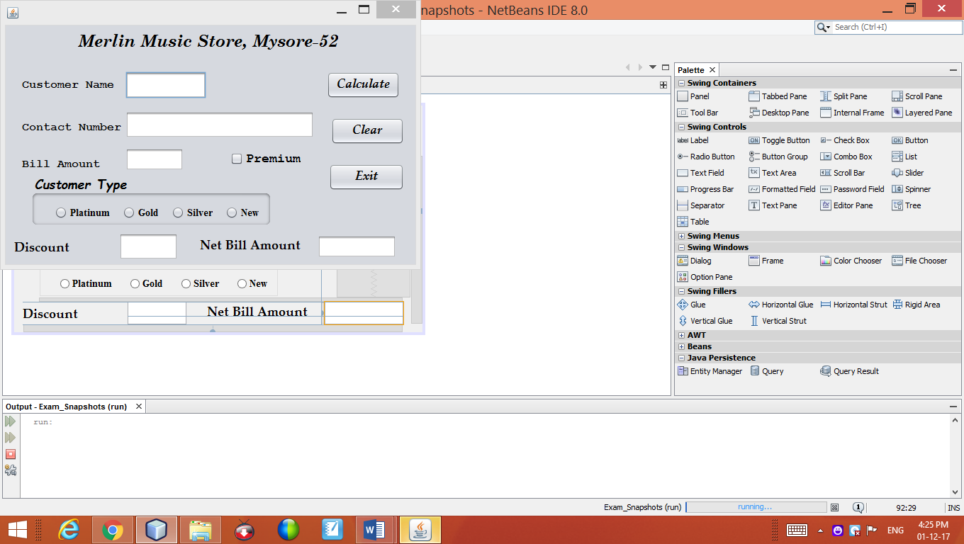  Use the following names for each control in the coding:  Control Name of the Control  Customer Name (Text Field) txtName  Customer number (Text Field) Txtnumber  Bill Amount (Text Field) txtAmount  Discount (Text Field) txtDisc  Net Amount (Text Field) txtNet  Platinum (Radio Button) optPlatinum  Gold (Radio Button) optGold  Silver (Radio Button) optSilver  New (Radio Button) optNew  Premium (Check Box) chkPremium  Clear (Button) btnClear  Calculate (Button) btnCalculate  Stop (Button) btnStop  Write the coding for the following:  - When the user clicks Calculate Button, Bill Amount and Discount & Net Amount to be paid should be calculated as follows: (3)  Customer Type Discount  Platinum 20 % of Bill Amount  Gold 15 % of Bill Amount  Silver 8 % of Bill Amount  New 5 % of Bill Amount  In addition, The Premium customer will get 5% discount extra!  Net Amount to be Paid = Bill Amount - Discount  - When the user clicks the Clear Button all the text fields, radio buttons and check box should be cleared. Also it disable the Clear button. (1)  - When the user clicks Exit Button, close the application. (1) | 5
4 a) | Sobha confused about the use of Primary Key and Unique Key. Help her to understand the differences between Primary Key and Unique Key. | 2
4 b) | Manish has a table Travel which has 8 rows and 6 columns. What is degree and Cardinality of the table Travel? | 1
4 c) | Mrs. Rekha a database developer created many tables in the database COMPANY. Later on She wants the see the all the available tables in it . Suggest her the commands which she should use to get the required information. | 2
4 d) | Define: Attributes and Tuples | 2
4 e) | Which command is used to see the list of available databases in MySQL? | 1
4 f) | Write the differences between Delete and Drop command in My SQL | 1
4 g) | Mr. Neeraj write the following Query to display all the details from the table SHOP in which Owner Name is not available.  SELECT * FROM SHOP WHERE OWNERNAME = NULL;  It displays the error Message! Help him to write the correct Query with out Error! | 1
5 a) | Create a table Library with the following field(s) specifications:  Table : LIBRARY  Field Name Field Data Type and Size Constraints  BookCode Int(10)  Title Varchar(25)  Publication Varchar(20)  Author Varchar(20)  Price Decimal(8,1) | 2
5 b) | Answer the following with reference to the above table LIBRARY:  - Write a command to add a constraint to Price column so that it stores value 100.00 automatically when the user fails to enter a value in it.  - Write the command to display the structure of the table LIBRARY.  - Write a command to add a column “PubDate” of date data type. | 3
5 c) | Create a table Customer with the following field(s) specifications:  Table : SUPPLIER  Field Name Field Data Type and Size Constraints  SupCode Varchar(5) Primary Key  SupName Varchar(30)  SupAddress Varchar(20)  EMail Varchar(15)  Credit Decimal(7,1) Less than 100000 | 2
5 d) | Answer the following with reference to the above table SUPPLIER:  - Write the command to remove the column EMail.  - Write the command to remove the SUPPLIER table.  - Write a command to increase the size of the column Supplier Address by 20. | 3
6 a) | Write SQL commands for the questions from (i) to (x) on the basis of table  Table Name : TEACHER (Each carries 1 mark)  SNo Name Age Department DateofJoin Salary Sex  1 Jugal 34 Computer 1997-01-10 12000 M  2 Sharmila 31 History 1998-03-24 20000 F  3 Sandeep 32 Science 1996-12-12 30000 M  4 Sangeeta NULL History 1999-07-01 40000 F  5 Rakesh 42 English NULL 24000 M  6 Shyam 50 History 1998-06-27 30000 M  7 Shiv Om 30 Computer 1997-02-25 21000 M  8 Shalakha NULL Maths 1997-07-31 20000 F  9 Junaid 28 Science 2000-06-12 Null M  10 Meena 25 English 2004-11-28 15000 F  - Display the details of the teachers whose Salary is below 25,000 .  - Display the Serial Number and Name of the female teachers.  - To add record with the following data: 11,“Joshna”,”Maths”,“16/June/2006”, 120000, ”F” into Serial No, Name, Department, Date of Join, Fee and Salary respectively.  - Display the details of teachers in ‘Computer’ and ‘English” department.  - Display the Name and Department of the teachers whose age is above 40.  - Display the details of all teachers whose date of join is after ’01/May/1997’.  - Display the details of Female Teachers whose age is not known.  - Display the Name and Date of Join of the teacher from ‘Science’ Department.  - Display the details in the ascending order of Join Date..  - Display the Name and Department of the teacher with the Serial Number 5. | 10
7 a) | Consider the following table RESULT and answer the questions given below:  NO SNAME STIPEND SUBJECT AVERAGE DIVISION  1 Sharon 400 English 38 Third  2 Jency 685 Mathematics 72 First  3 Vedant 500 Accounts 82 First  4 Zakeer Null Informatics 55 Second  5 Anandhi 400 History 85 First  6 Umesh 550 Geography 45 Third  - Select * from Result where Average>=75 and Average<=90;  - Select SName, Stipend from Result Where Average<60 Order By SName;  - Select SName, Subject, Average from Result where SName like ‘%an%’;  - Select Distinct Division from Result;  - Select No, SName, Stipend from Result where Subject in (‘Accounts’, ‘English’);
7 b) | Answer the following with reference to the above table RESULT:  - Delete the records from the above table in which Average is more than 80.  - Delete the records from the above table of the Division ‘Third’.  - Delete the records from the above table in which Stipend is not available.  - Delete the records from the above table in which Student Name consists of 5 letters.  - Delete the records from the above table in which Name Start with the letter ‘V’. | 5

All the Best

