|  |
| --- |
| **INDIAN SCHOOL AL WADI AL KABIR**  **DEPT. OF COMPUTER SCIENCE**  **CLASS VIII WINTER Holiday Homework 2017-18** |

CREATE FOLLOWING WEBPAGE USING <IMG>TAG, with all its attributes to display it in attractive manner

Hint: Use height, width, align, border and heading tags

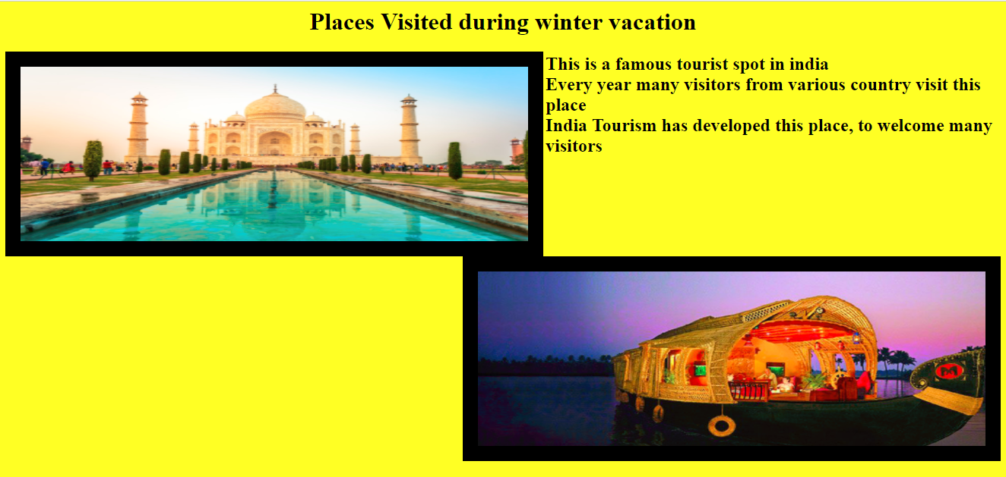

**Remark: Holiday Homework Practice at Home and write the code in notebook, Evaluation will be done after holidays during the regular practical session.**

**☺ HAPPY HOLIDAYS ☺**