INDIAN SCHOOL AL WADI AL KABIR
Handout - Project Development Using Java Database Connectivity (2017-18)
Class: XII | Informatics Practices | 07.05.2017
Step 1 : Open My SQL. Create a Database Stockdb and create a table stock with the fields to store item code(int), item name(varchar), item type(varchar), item price(float) and available stock(int).

Step 2 : Open Java Net beans, create a project and include a jframe to design the item data form with 4 text fields and 1 combo box to store the item details. Include 6 buttons for Add, Delete, Update, Search, Clear and Close operation. Also include a JOptionPane to the frame to display messages.
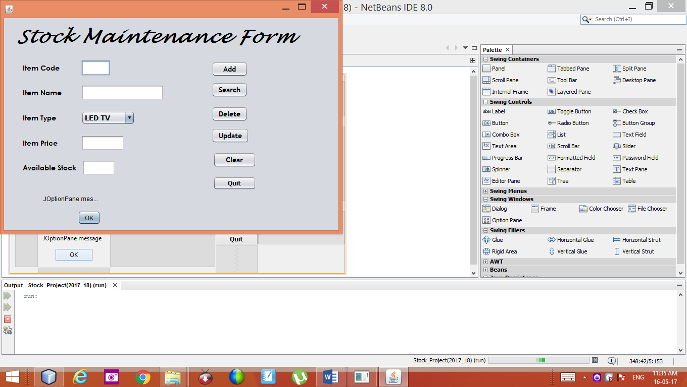
Step 3 : Select File Menu – Choose Project Properties – Select Libraries Tab – Add Library – Select My SQL JDBC Driver – Click Add Library and Click OK.

Step 4 : In the Source code area at the beginning include the following code…
import java.sql.*;

Step 5 : Include the following statements in the coding of the class stock form.
Statement stmt=null; ResultSet rs=null;
String query="Select * from stock";

Step 6 : Enter the following code in the corresponding button to run the application.
Coding for Add Button
private void AddActionPerformed(java.awt.event.ActionEvent evt) {
int icode=Integer.parseInt(jTextField1.getText());
String iname=jTextField2.getText();
String itype=(String) jComboBox1.getSelectedItem();
float iprice=Float.parseFloat(jTextField3.getText());
int avs=Integer.parseInt(jTextField4.getText());
try {
Class.forName("java.sql.Driver");
Connection con=DriverManager.getConnection("jdbc:mysql://localhost/stockdb","root","mysql");
Statement stmt=con.createStatement();
String query="insert into stock values (" +icode + "," + "'" +iname +"'" +"," +"'" +itype +"'" +"," +iprice+","+ avs+");";
stmt.executeUpdate(query);
jOptionPane1.showMessageDialog(this,"Record is Added Successfully");
}
catch(Exception e) {
jOptionPane1.showMessageDialog(null,e.getMessage());
}
}
Coding for Search Button
int sicode=Integer.parseInt(jTextField1.getText());
try {
Class.forName("java.sql.Driver");
Connection con=DriverManager.getConnection("jdbc:mysql://localhost/stockdb","root","mysql");
Statement stmt=con.createStatement();
String query="Select * from stock where itemcode = "+sicode+";";
ResultSet rs=stmt.executeQuery(query);
if(rs.next()) {
int icode=rs.getInt("itemcode");
String iname=rs.getString("itemname");
String itype=rs.getString("itemtype");
float iprice=rs.getFloat("itemprice");
int avs=rs.getInt("Available_stock");
jTextField1.setText(""+icode); jTextField2.setText(""+iname);
jComboBox1.setSelectedItem(itype); jTextField3.setText(""+iprice);
jTextField4.setText(""+avs);
con.close(); stmt.close(); rs.close();
}
else
jOptionPane1.showMessageDialog(null,"Record does not found in the Stock Table...");
}
catch(Exception e) {
jOptionPane1.showMessageDialog(this,e.getMessage());
}
}
Coding for Delete Button
int dicode=Integer.parseInt(jTextField1.getText());
try {
Class.forName("java.sql.Driver");
Connection con=DriverManager.getConnection("jdbc:mysql://localhost/stockdb","root","mysql");
Statement stmt=con.createStatement();
String query="Delete from stock where itemcode = " +dicode+";";
int No_Rows=stmt.executeUpdate(query);
if(No_Rows==0)
jOptionPane1.showMessageDialog(this,"Record does not exists...");
else
jOptionPane1.showMessageDialog(this,"Record is deleted...");
}
catch(Exception e) {
jOptionPane1.showMessageDialog(this,e.getMessage());
}
}
Coding for Update Button
float uiprice=Float.parseFloat(jTextField3.getText());
int uicode=Integer.parseInt(jTextField1.getText());
try {
Class.forName("java.sql.Driver");
Connection con=DriverManager.getConnection("jdbc:mysql://localhost/stockdb","root","mysql");
Statement stmt;
stmt=con.createStatement();
String query="Update stock set itemprice = "+uiprice+" where itemcode="+uicode+";";
jOptionPane1.showMessageDialog(this,"Record is Updated");
stmt.executeUpdate(query);
con.close(); stmt.close();
}
catch(Exception e) {
jOptionPane1.showMessageDialog(this,e.getMessage());
}
}
Coding for Clear Button:
jTextField1.setText(""); jTextField2.setText(""); jTextField1.setText("");
jTextField2.setText(""); jComboBox1.setSelectedItem("LED TV");

Coding for Quit Button: System.exit(0);

