INDIAN SCHOOL AL WADI AL KABIR
DEPARTMENT OF SCIENCE 2016-17
CLASS: X - REVISION WORKSHEET
PHYSICS
- State the law of refraction of light that defines the refractive index of one medium with respect to the other.
b) Express it mathematically also.
c) Write the expression relating the refractive index of medium ̳A‘ with respect to the

medium
B‘ to the speed of light in the two media ̳A‘ & ̳B‘. Name the constant when medium

B‘ is vacuum.
2. 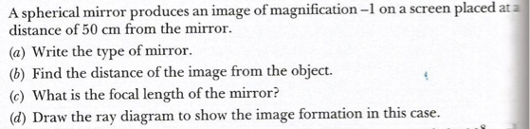
3. 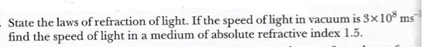

4.
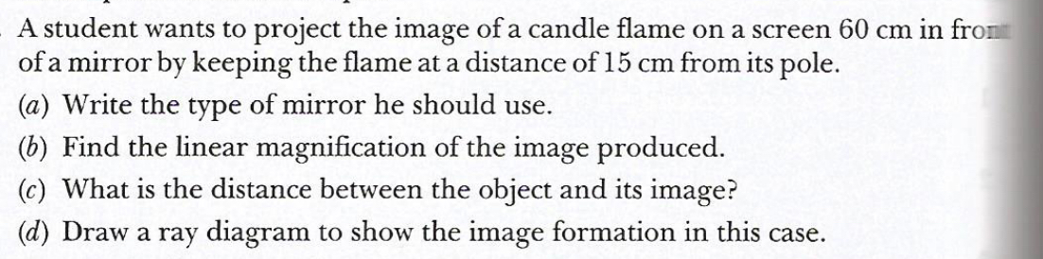

5. 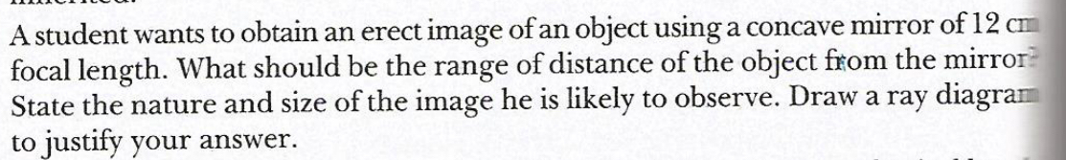

6. Explain why a ray of light passing through the centre of curvature of a concave mirror, get s reflected along the same path.
7.What is the nature of the image formed by a concave mirror if the magnification produced by the mirror is + 3?
8 .Between which two points of a concave mirror should an object be placed to obtain a magnification of – 3?
9. "The refractive index of carbon disulphide is 1.63." What is the meaning of this statement in relation to speed of light?
10. Between which two points related to a concave mirror should an object be placed to obtain on a screen an image twice the size of the object?

CHEMISTRY

- 1. Two compounds „A‟ and „B‟ have the molecular formula C₃H₈ and C₃H₆ respectively. Which one of the two is most likely to show addition reaction ? Justify your answer. Explain with the help of a chemical equation, how an addition reaction is useful in vegetable ghee industry.

- An organic compound ‘A’ of molecular formula C₂H₆O on oxidation with dilute alkaline KMnO₄ solution gives an acid ‘B’ with the same number of carbon atoms. Compound ‘A’ is often used for sterilization of skin by doctors.
(i) Name the compounds ‘A” and ‘B’.
(ii) Write the chemical equation involved in the formation of ‘B’ from ‘A

- (i) How will you bring about following reactions ? Write the concerned chemical equation : (a) Ethanol to Ethane (b) Ethanol to Ethanoic acid. (ii) Give one example with chemical equation for following reactions : (a) Substitution reaction. (b) Saponification reaction. (c) Combustion reaction.

- (a) Write the name of the following compound : CH₃CH₂COOH, C₆H₆ (b) What is a homologous series ? Write the formula of functional group of ketone and aldehyde
- (i)When a compound X reacts with another compound Y in the presence of an acid catalyst, a sweet smelling compound Z is produced. What are X and Y ? Write the chemical equation for this reaction
(ii) What happens when the compound Z combine with an acid or a base? Write the name and chemical equation of the reaction

BIOLOGY
1)Give any two examples for unisexual flowers.
2) State the functions of prostate gland and seminal vesicles.
3)Differentiate between self pollination and cross pollination.
4)How is the DNA stability maintained in sexually reproducing organisms?
5)What are the post fertilisational changes in sexually reproducing plants?
6)In pea plants,green colour seeded plant was crossed with yellow colour seeded plant.All the F1
Generation was found to be green seeded.
i)What type of cross is it?
ii)Give the typical F2 genotypic ratio.
7)How do traits get expressed?
8)Explain the function of the following :
i)fallopian tube ii)uterus iii)vagina
9)Sex in humans is genetically determined.Explain.
10)Briefly explain the mechanism of fertilisation in sexually reproducing plants
Prepared by Ms. Jenesha, Ms. Asha and Ms. Zeema

