20

FA-IV REVISION WORKSHEET

CLASS VI



2016

PREPARED BY

SHRUTI MUKUNDAN

CLASS COORDINATOR

INDIAN SCHOOL AL WADI AL KABIR

DEPARTMENT OF SCIENCE 2016-17

REVISION WORKSHEET DATE: 13-12-2016

CLASS: VI FORMATIVE ASESSMENT -IV NAME:

Answer the following questions:

**MOVEMENTS IN THE BODY**

1. Name the sensory structure in cockroach.
2. What do you mean by a streamlined body?
3. Write the importance of swim bladder in the fishes.
4. What are the important features which enable birds to fly?
5. Name any two flightless birds. Why can’t they fly?
6. Mention the structures which enable a snake to move.
7. What is skeleton? What are the various functions of human skeleton.
8. Observe the figures given below and answer the questions that follow:

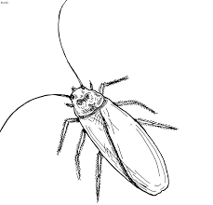 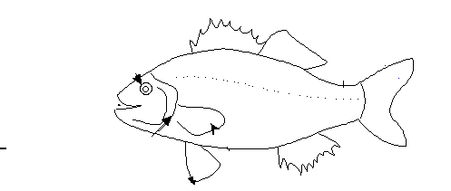

A B

a) Name the type of skeleton in B

b) What is the importance of the sensitive antennae in organism B?

c) Organism A has a sac-like structure inside the body. Name it and state its use.

d) Write the importance of fins in organism A.

9. Identify the parts of the human skeleton and mention their functions

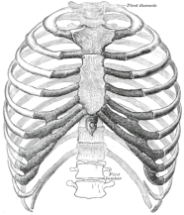 A B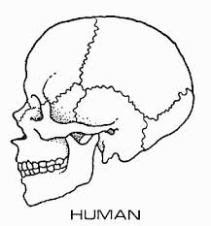

10. What are joints?

11. Write the difference between Hinge joint and ball and socket joints.

12. Differentiate between ligaments and tendons.

13. How do muscles attached to bones bring about movement? Explain with an example.

14. Identify the type of joints found in the parts marked in the given diagram. Also write their

functions.

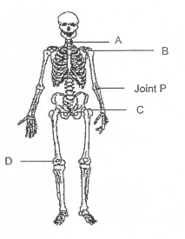

15. What are X- rays? Write the importance of X-rays in the field of medicine.

16. Why are last two pairs of ribs known as` floating ribs’?

17. Differentiate between vertebrates and invertebrates with suitable examples.

18. Write the importance of spine in the human body. How many vertebrae join to form a

a vertebral column.

19. What are fixed joints? Name the only movable joint in the skull.

20. Label the bones found in both fore limbs and hind limbs in the given diagram.

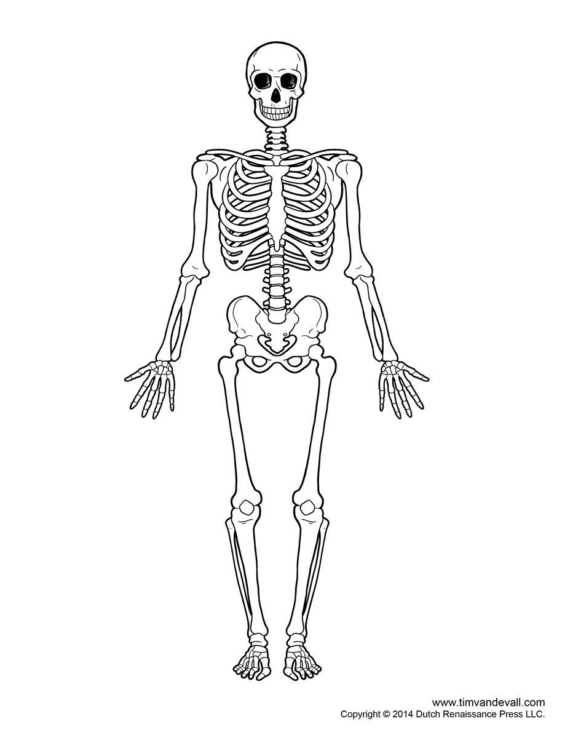

**ADAPTATIONS IN THE LIVING ORGANISMS**

1. Define adaptation.
2. Differentiate between biotic and abiotic components in the environment.
3. What is a habitat?
4. Give two examples for arboreal organisms.
5. A camel lives in a desert where there is very little water, whereas a fish lives in water.

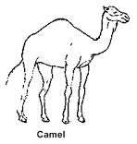 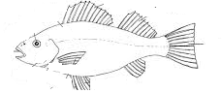

How are they adapted to live in their natural surroundings?

1. Observe the picture given below and answer the following questions

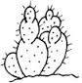

1. Which habitat would one find the plant shown above?
2. Why leaves are turned into spines in this plant?
3. Give reason why it has a flat green stem and its roots go deep into the soil.

7. Give reasons.

a) Ducks have oil glands under their tails.

b) Fully submerged hydrophytes have either ribbon shaped or highly divided leaves.

c) Conifers are cone shaped with needle shaped leaves.

8. What is hibernation?

9. How does a kangaroo rat survive without drinking water for several years?

10. Give any two adaptive features of flora in grasslands.

11. Lion and deer are found in grasslands. Both have remarkable speed. What is the

significance of speed in grasslands?

12. Explain why:



a) Lion has eyes in the front of its head.

b) A deer has eyes placed on the sides of its head.

13. Observe the given figure and answer the following questions:

a) Why are the leaves of this plant tough?

b) Name one adaptive feature of its stem.

14. Name any two fully submerged aquatic plants. Also write any four adaptive features.

15. What do you mean by camouflage? How does it help the organisms? Name any two

organisms which can camouflage?

16. Write down the adaptive features of the given polar organisms.

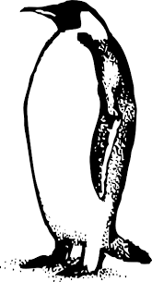

A

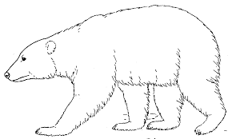

B

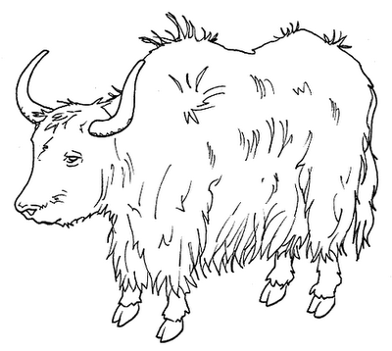

C

17. Why leaves of plants in tropical rainforest have drip trips?

18. Give any for functions of adaptation.

19. Name one adaptive feature of the animal shown below:



20. Give any two adaptive features of grazing animals.

**MESUREMENT AND MOTION**

1. Define measurement. What is unit in a measurement?
2. Why do we need standard units for measurement?
3. Give the advantages of SI units.
4. Explain any two traditional units of measuring length.
5. Why are handspan and cubit not considered as standard units?
6. Describe parallax error.
7. Give the precautions to be taken while measuring a quantity with a ruler.
8. When is an object said to be in motion?
9. Differentiate between periodic and non-periodic motion
10. Define oscillatory motion. Give two examples.
11. Identify the types of motion in the following examples :
12. The movement of needle in a sewing machine.

(b) Spinning of a top.

(c) Motion of plucked string of a guitar.

(d) Movement of a see saw.

1. Convert

a) 120 cm = …………m.

b) 1425 m= ………….km

c) 36 min= ………….s

d) 750 g= …………kg

13. Identify the type of motion in the following.

[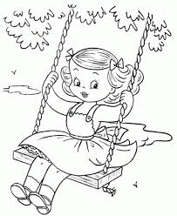](http://www.google.com/url?sa=i&rct=j&q=&esrc=s&source=images&cd=&cad=rja&uact=8&ved=0CAcQjRw&url=http://printablecolouringpages.co.uk/?s=playing+on+swing&ei=SU3nVPCgE4XVapWfgOgL&psig=AFQjCNFMaxN2ha_zgnhwzFznSK3UKio-Vw&ust=1424531109116989)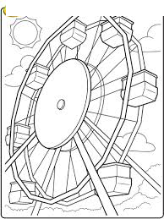

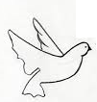

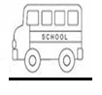

D

C

B

A

14. When is an object said to be at rest?

15. Measure the given curved line using both thread and divider method. Also write the procedure

PREPARED BY

SHRUTI MUKUNDAN

CLASS COORDINATOR

for the same.

